Frequently Asked Questions

Recall of DS 40F

How do I know which FreeSpace DS 40F loudspeakers are affected by this recall?
If the FreeSpace DS 40F loudspeaker was manufactured by Bose Professional before August 13, 2018, then it is included in this recall.
If a FreeSpace DS 40F loudspeaker was manufactured by Bose Professional on or after August 13, 2018 or if you are unsure when your loudspeaker was purchased from Bose Professional, follow these steps:

- Determine if the loudspeaker is pendant-mounted.
If the loudspeaker is pendant-mounted, it is NOT included in this recall. A pendant-mounted FreeSpace DS 40F looks like this:
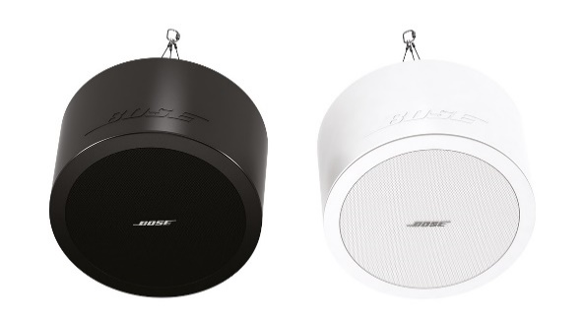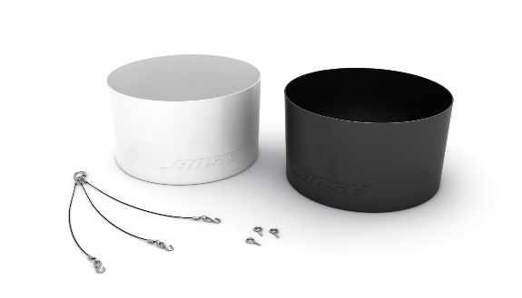
However, if the loudspeaker is in-ceiling/flush-mounted go to Step 2 to determine if the loudspeaker is included in this recall. An in-ceiling/flush-mounted FreeSpace DS 40F looks like this:
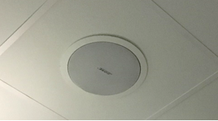

- Find the original paperwork (e.g. Bose Professional order confirmation, shipping confirmation, or invoice) and check for the below product codes.
If you cannot locate the original paperwork, continue to Step 3 to determine if your loudspeaker is included in this recall.
If the paperwork includes one of the following product codes, stop here; your loudspeaker(s) is included in this recall.

Product Codes | Description | Color
321278-0110 | FS DS40F LDSPKR BLK | Black
321278-0120 | FS DS40F LDSPKR 8OHM BLK | Black
321278-0210 | FS DS40F LDSPKR WHT | White
321278-0220 | FS DS40F LDSPKR 8 OHM WHT | White
321278-0130 | FS DS40F LDSPKR BLK | Black
321278-0140 | FS DS40F LDSPKR 8 OHM BLK | Black
321278-0230 | FS DS40F LDSPKR WHT | White
321278-0240 | FS DS40F LDSPKR 8 OHM WHT | White
321278-0250 | FS DS40F VA LDSPKR ASSY, WHT | White
321278-023R | FS DS40F LDSPKR WHT FR | White
321278-024R | FS DS40F LDSPKR 8 OHM WHT FR | White
321278-025R | FS DS40F VA LDSPKR ASSY, WHT FR | White

European Product Codes:
Product Codes | Description | Color
47627 | FS DS40F LDSPKR BLK | Black
47628 | FS DS40F LDSPKR WHT | White
47630 | FS DS40F LDSPKR 8 OHM WHT | White
48451 | FS DS40F LDSPKR BLK | Black
48452 | FS DS40F LDSPKR WHT | White
48453 | FS DS40F LDSPKR 8 OHM WHT | White
60265 | FS DS40F VA LDSPKR ASSY, WHT | White

- If possible, without removing the loudspeaker from its installed location, look at the label on the back of the loudspeaker and locate the date of manufacture (DOM) number. If you cannot safely access the back of the loudspeaker, continue to Step 4 to determine if your loudspeaker is included in this recall. Do NOT remove the loudspeaker from its installed location to look for the DOM number.
The DOM number is the underlined 4-digit number following the Z in the product’s serial number. If the DOM number is 8224 or lower, stop here; your loudspeaker is included in the recall.
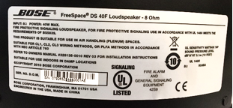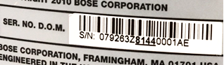
The DOM above, 8144, is lower than 8224, and is therefore included in the recall.

- Have the loudspeaker measured.
IMPORTANT: For safety reasons, this should be done only by a professional installer.

Step 4a: Measure the outer flange diameter.
If the outer flange diameter is less than 300 mm (11.8 in), stop here; the loudspeaker is NOT included in recall.
If the outer flange diameter is 300 mm, proceed to Step 4b.
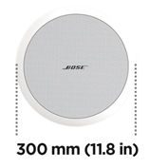
Step 4b: If the outer flange diameter is 300 mm (11.8 in), remove the loudspeaker grille.
If there are two drivers, the loudspeaker is a DS 100F and it is not included.
If there is one driver, measure the driver diameter. As stated above, this should only be done by a professional installer. Be very careful to not damage the grille when removing it.
If the driver diameter is 114 mm (4.5 in), the loudspeaker is included in this recall.
Note: If having a professional take measurements is not possible or if you otherwise cannot determine if the FreeSpace DS 40F loudspeaker is included in the recall using these steps, please contact us for help: boseprofessional.com/bmssafety.
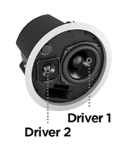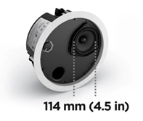

What is the issue with the DS 40F loudspeakers that is causing this recall?
We have found that, due to a design issue, the mounting anchors on DS 40F loudspeakers can break, which could cause the loudspeakers to fall and result in serious injury. This issue has been resolved on all DS 40F loudspeakers manufactured after August 13, 2018.

What is the date range of the loudspeakers that are impacted?
All FreeSpace DS 40F loudspeakers manufactured before August 13, 2018 are being recalled.

How does this affect the product warranty?
All replacement FreeSpace DS 40F loudspeakers include a new warranty. The warranty period for all replacement FreeSpace DS 40F loudspeakers will begin on the date of installation. For information on the FreeSpace DS 40F loudspeaker warranty, go to boseprofessional.com/warranty.

What should I do with the old loudspeakers?
Visit boseprofessional.com/bmssafety and follow the instructions to request replacement product. You will also receive direction from us to either return or destroy the loudspeakers removed from installations. You must send us the recalled loudspeaker or proof of destruction within 120 days or your account will be charged.

What is the risk of not replacing an affected FreeSpace DS 40F loudspeaker?
If all three anchors on an affected FreeSpace DS 40F unit fail, the unit could fall and result in personal injury or property damage.

Can I use this safety cable instead of replacing the recalled DS 40F loudspeakers?
No, all recalled DS 40F loudspeakers must be replaced. Additionally, the replacement loudspeaker requires a safety cable if it is located in the same room as a cooking surface or is exposed to the air from a room with a cooking surface via an HVAC system with an above-ceiling plenum return.

Should a FreeSpace DS 40F loudspeaker be replaced even if it is already attached via a safety cable to the ceiling?
Yes. All affected DS 40F loudspeakers must be replaced.

Is the issue affecting the DS 40F present in any other Bose Professional products?
No other Bose Professional products are affected by this issue.

Can I still use rooms that have FreeSpace DS 40F loudspeakers installed?
Until they are removed, keep people and property away from the area beneath the loudspeakers.

When does the replacement need to be completed?
Because we are replacing units to avoid potential safety hazards, all affected loudspeakers should be replaced immediately.

Can an end user replace their own FreeSpace DS 40F?
The FreeSpace DS 40F requires installation by a professional installer. End users who are not professional installers should not attempt to replace the speaker on their own, and instead should contact their Bose Professional dealer.

What if the loudspeakers are custom painted?
If replacing a custom-painted loudspeaker poses a problem, please contact us for assistance.

Can I continue to specify FreeSpace DS 40F loudspeakers?
Yes. If you have any concerns, contact your Bose Professional Sales Representative. Please note that any DS 40F loudspeakers installed in commercial cooking environments require the use of a safety cable, which is provided with new units. Please review the design guidelines on the affected product pages at boseprofessional.com.

I have FreeSpace DS 40F loudspeakers in my inventory that are included in this recall. What should I do?
If you have affected FreeSpace DS 40F loudspeakers in your inventory, do not sell or install them. Please visit boseprofessional.com/bmssafety for instructions.

How are you communicating the DS 40F recall?
Bose Professional is contacting anyone who purchased product from us directly as well as posting a notice on boseprofessional.com. In addition, we are instructing our distributors and resellers to communicate the recall to their customers and are also conducting targeted social media campaigns to reach product owners with whom we would not ordinarily have direct contact.

Do I need to install a safety cable with the replacement product?
If replacing a DS 40F in commercial cooking environment, you must also install a safety cable with the replacement loudspeaker. For more information about this, please see the “Installation of Safety Cables” FAQ below. Although recommended as a precaution in all installations, safety cables are not required on loudspeakers in spaces other than commercial cooking environments unless required by local codes or regulations.

Can I use a small amount of lubricant to help with installation of replacement DS 40F loudspeakers?
No, DS 40F loudspeakers must never be exposed to hydrocarbon-based solvents, cleaning solutions, or lubricants, such as WD-40, during or after installation. These materials can degrade the loudspeaker and cause it to fall.

Can I simply swap the mounting arms instead of swapping the entire loudspeaker?
No. The part is not field-replaceable. Bose Professional will provide a complete replacement loudspeaker.

What if I’ve sold FreeSpace DS 40F loudspeakers to a system integrator who is no longer in operation and we have no trace of their products?
You should use every effort to identify all customers to whom you have supplied FreeSpace DS 40F loudspeakers and notify them of the recall at their current place of business or last known address.

What if the system integrator does not want to replace the FreeSpace DS 40F loudspeakers even if we refund all the costs?
You should reiterate the serious potential safety hazard posed by the loudspeakers and try to resolve any factors causing the customer’s resistance. If you need additional assistance, you may contact Bose Professional at boseprofessional.com/bmssafety.

What if the end user/installation site owner does not want to have their FreeSpace DS 40F loudspeakers replaced?
You should reiterate the serious potential safety hazard posed by the loudspeakers and try to resolve any factors causing the customer’s resistance. In some jurisdictions, it would be a violation of law to disregard this issue and continue using the product.

What if the owner of a business (e.g. retail store, fitness studio) wants to charge us for the downtime during the replacement?
Bose Professional has established a per-unit amount to compensate dealers and distributors for their installation and related costs. We have considered many factors, including night labor, staging and lift rental, security needs, and travel to ensure we are fairly compensating our dealers and distributors for their effort. We believe the per-unit compensation amount is sufficient to allow the scheduling flexibility needed to prevent downtime for end users. In the event an end-user customer has extraordinary circumstances such as downtime, please contact your Bose Professional Sales Representative for assistance.

How will Bose Professional compensate system integrators for the impact of replacing FreeSpace DS 40F loudspeakers in my customers’ facilities?
Bose Professional will compensate system integrators at a fixed per-unit rate to remove and replace the recalled FreeSpace DS 40F loudspeakers. We’ll process this payment once we have received the impacted units back at our facility. Please see the FreeSpace DS 40F Compensation Schedule for details on the labor compensation program.

Who should I contact with media inquiries?
Amanda_Roe@boseprofessional.com

Installation of Safety Cables

What is the issue with the affected loudspeakers that is causing this field action?
We have found that the mounting components on some of our loudspeakers can degrade and break when exposed to certain substances. Cooking oils and lubricants are the only substances to which the affected loudspeakers are likely to be exposed at levels high enough to degrade their mounting components.

What is the risk of not installing safety cables on the impacted loudspeakers in commercial cooking environments?
If the mounting components on the loudspeaker are exposed to cooking oil or cooking oil fumes they may fail, which could cause the unit to fall and result in personal injury or property damage.

How do I determine if the loudspeaker requires a safety cable?
The loudspeaker requires a safety cable if it is located in the same room as a cooking surface or is exposed to the air from a room with a cooking surface via an HVAC system with an above-ceiling plenum return.

What is an HVAC system with an above-ceiling plenum return?
An HVAC is a system that provides heating and cooling services to a building. An above-ceiling plenum return is a separate space between the structural ceiling and a drop-down ceiling that allows for air circulation for the HVAC as depicted in the image below.
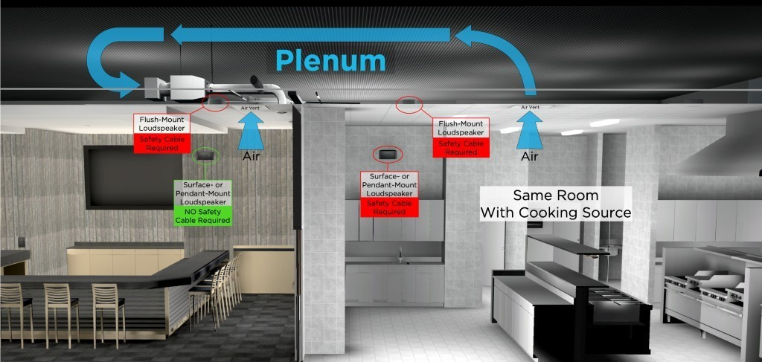

What do you mean by “in the same room”?
You should consider the loudspeaker to be in the same room as the cooking surface unless it is separated from the cooking space by full-height walls, full-height doors and wall openings that normally remain closed.

Can I use a small amount of lubricant to help with installation?
No, the affected loudspeakers must never be exposed to hydrocarbon-based solvents, cleaning solutions, or lubricants, such as WD-40, during or after installation. These materials can also degrade the loudspeaker, and if used on or near the loudspeaker’s mounting components they could cause the mounting components to fail. The loudspeaker should only be cleaned/dusted using a dry cloth.

Which Bose Professional loudspeaker models are affected?
The following Bose Professional loudspeaker models are affected, including all SKU variants of these models, as well as mounting accessories such as brackets and pendant kits.

In-ceiling/Flush-mount Models | Surface-mount Models
EdgeMax EM90 (certain SKUs, see below)  EdgeMax EM180 (certain SKUs, see below)  FreeSpace DS 16F  FreeSpace DS 40F  FreeSpace DS 100F  FreeSpace 3 Flush-Mount Satellites (certain SKUs, see below)  FreeSpace 3 Series II Acoustimass (bass) module (certain SKUs, see below) | FreeSpace DS 16S / 16SE  FreeSpace DS 40SE  FreeSpace DS 100SE

NOTE: Only certain EdgeMax EM90 and EM180, and FreeSpace 3 SKUs are affected:

SKUs still requiring safety cable installation in commercial cooking environments:
778844-0210 (EM90)
777189-0210 (EM180)
40147 (FS3 Flush Bass Module, White)
40148 (FS3 Flush Bass Module, Black)
40149 (FS3 Flush Satellite, White)
40150 (FS3 Flush Satellite, Black)

SKUs not requiring safety cable installation in commercial cooking environments:
778844-0220 (EM90)
777189-0220 (EM180)
843090-0210 (FS3 Flush Bass Module, White)
843090-0110 (FS3 Flush Bass Module, Black)
843091-0210 (FS3 Flush Satellite, White)
843091-0110 (FS3 Flush Satellite, Black)

If I receive a new FreeSpace 3 or EdgeMax product, do I have to use a safety cable?
Although recommended as a precaution as a secondary securing mechanism in all installations, when using new FreeSpace and EdgeMax SKUs listed above, safety cables are not required unless otherwise mandated by local codes or regulations.

Can I receive a new version of FreeSpace 3 or EdgeMax to replace the current version instead of installing safety cables in an existing installation?
We are not providing new versions of FreeSpace 3 or EdgeMax in place of safety cables or current versions of FreeSpace 3 or EdgeMax requiring safety cables in commercial cooking environments.
There is no limit to the number of safety cables you may order from Bose Professional free of charge, however, for use with existing FreeSpace 3 and EdgeMax products in commercial cooking environments.

Why are you making this change?
We are making this change because of Bose Professional’s commitment to continuing to improve the quality of our products and the experience of our customers. The updates to FreeSpace 3 and EdgeMax are the result of research into different materials, as well as feedback from customers since the launch of the product.

Why didn’t you make this change before announcing the need for safety cables?
Implementing the use of safety cables for products already installed in commercial cooking environments was the fastest path to preventing a potential safety hazard for our customers and end users.

What if I go to install a safety cable and find that the loudspeaker is visibly damaged, either by exposure to cooking oil or through the process of installing the safety cable?
Contact your Bose Professional Sales Representative to receive a replacement loudspeaker. All replacement loudspeakers include a new warranty beginning on the date of installation. For information on Bose Professional’s standard product warranty, go to boseprofessional.com/warranty.

How can I be sure that safety cables adequately address this issue?
We have tested the provided safety cable, and if properly installed, it will prevent the loudspeaker from falling.

What if I am unable or unwilling to install safety cables where required?
Remove the loudspeaker and return it to Bose Professional for a refund.

How do I learn how to install the safety cables?
Instructions will be provided with the safety cables. In addition, instructions can be found on each product page at boseprofessional.com.

How do I obtain the safety cables for installation inspections?
Safety cables will be provided by Bose Professional free of charge. To obtain cables for loudspeakers that are already installed, visit boseprofessional.com/bmssafety. Any new [affected] products purchased from Bose Professional will have safety cables in the box with the product.

What if the rear cover plate of my loudspeaker is missing?
If rear cover plates are missing from the installed loudspeakers, please contact your Bose Professional Sales Representative to order them free of charge.

How long will I be required to install safety cables for new installations in commercial cooking environments?
Although recommended as a secondary securing mechanism in all installations, safety cables are required only for previous FreeSpace 3 and EdgeMax SKUs, and all FreeSpace SKUs (i.e. DS16, DS40, DS100) installed in commercial cooking environments. They are no longer required for new FreeSpace 3 and EdgeMax products unless otherwise mandated by local codes or regulations and are therefore not provided in the box with the new SKUs mentioned in this document. Safety cables are still provided with all FreeSpace SKUs.

What type of safety cables are you providing?
Two types of cables are available. These cables will work in most circumstances.
Safety Cable Use | Part Number | Description
In-ceiling/flush-mount and pendant loudspeakers (other than the FreeSpace 3 Series II Acoustimass Module) | 839760-0010 | 6 meters (20 feet), closed loop on one end, open on other end, includes Gripple fastener
Surface-mount loudspeakers and the FreeSpace 3 Series II Acoustimass Module | 839761-0010 | 1.5 meters (5 feet), 90-degree eyelet on one end, open on other end, includes Gripple fastener

What if the provided safety cables are not long enough for my installation?
If the provided safety cables are not long enough, you can substitute a longer safety cable only if it meets the following requirements. Failure to meet these requirements could cause the loudspeaker to fall and result in personal injury or property damage.

Safety Cable Specification
Type: Galvanized high-tensile steel cable, to EN12385.
Diameter: 2 mm (5/64 in)
Strand Configuration: 7x7

Attachment Method
After installation, both the loudspeaker and the building structure must be captured within the cable via loops (as depicted in the diagram provided below). Hooks or other open attachment methods must not be used.
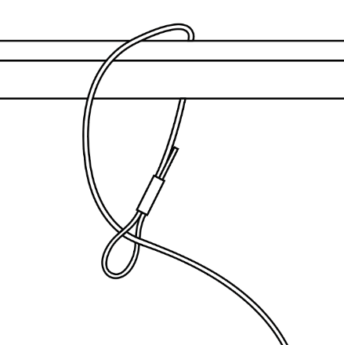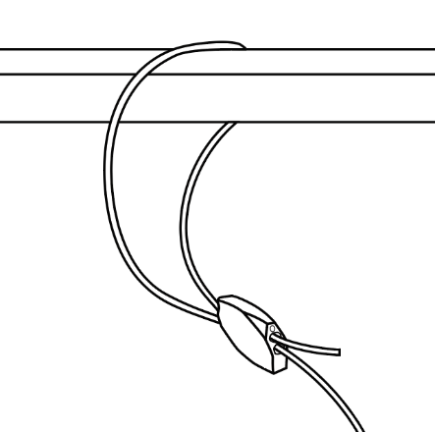

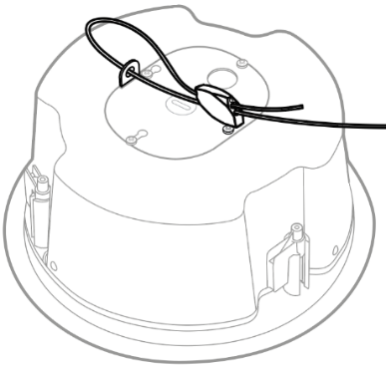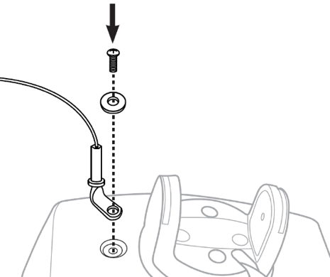
If you provide your own cable, you must remove the slack from the safety cable such that, in the event of a fall, the top (rear) of the loudspeaker will drop to a distance of no more than 152 millimeters (6 inches) below the ceiling (if it is a flush-mount loudspeaker) or from its mounted location (if it is a surface-mount loudspeaker) before it is retained by the safety cable.

Cable Length
For flush-mount loudspeakers, remove slack from the safety cable such that, in the event of a fall, the top (rear) of the loudspeaker will drop to a distance of no more than 152 millimeters (6 inches) below the ceiling before it is retained by the safety cable.
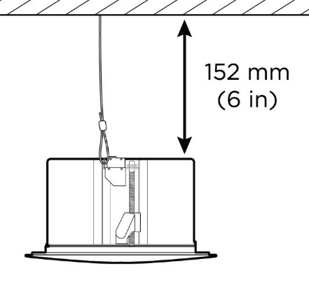
For surface-mount loudspeakers, remove slack from the safety cable such that, in the event of a fall, the loudspeaker will not drop more than 152 millimeters (6 inches) from its mounted location before it is retained by the safety cable.
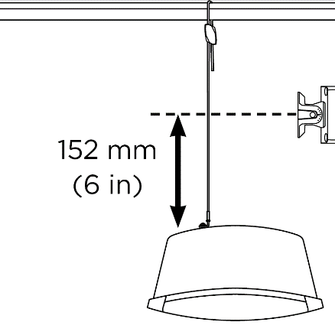

If I have to provide my own safety cables, will you reimburse me for the cost?
Yes. Please contact your local Bose Professional Sales Representative.

Can you send me extra safety cables?
Yes. There is no limit to the number of safety cables you may order from Bose Professional free of charge. Please note that although recommended as a secondary securing mechanism in all installations, safety cables are no longer required for new FreeSpace 3 and EdgeMax products unless otherwise mandated by local codes or regulations. Safety cables are still required, however, for previous FreeSpace 3 and EdgeMax SKUs, and all FreeSpace SKUs (i.e. DS16, DS40, DS100) installed in commercial cooking environments.

Are safety cables still provided in the boxes of all new products?
Safety cables are still provided for all products that require a safety cable in order to be safely installed in commercial cooking environments other affected products. Safety cables are not provided with the new FreeSpace 3 and EdgeMax SKUs because the designs are more resilient to cooking oil exposure.

Can I get safety cables for use with the new FreeSpace or EdgeMax SKUs anyway?
Yes; we understand that customers may still utilize safety cables as a secondary securing mechanism. There is no limit to the number of safety cables you may order from Bose Professional free of charge until further notice.

Will you be updating the materials in other products involved in the Recall and Safety Cable Inspection/Installation?

No. Only EdgeMax and FreeSpace 3 products will be updated.

What about loudspeakers in spaces that are not commercial cooking environments?
Although recommended as a precaution in all installations, safety cables are not required on loudspeakers in spaces other than commercial cooking environments unless required by local codes or regulations.

What if my loudspeakers are mounted with a pendant kit?
A pendant-mounted loudspeaker requires a safety cable if it is located in the same room as a cooking surface.

What about products installed in outdoor cooking areas?
While outdoor cooking environments generally have higher levels of ventilation, safety cables must be used for loudspeakers in close proximity to the cooking area or if the loudspeaker will be exposed to cooking oil or cooking oil fumes. If you have any uncertainty about whether a safety cable should be used, we recommend installing it.

What do I say if my customer (an end user) asks me why we are installing safety cables?
Because the mounting components could break if they’re exposed to cooking oil or cooking oil fumes.

Do you know of any other manufacturers that have this issue?
We do not know if any other manufacturers are having this issue. We are working aggressively to resolve the issue with our products. It would not be appropriate for us to speculate on other manufacturers’ products.

I am replacing DS 40F loudspeakers as part of the recall. Do the replacement loudspeakers require safety cables?
Yes, if the DS 40F loudspeaker is installed in a commercial cooking environment then a safety cable is required.

Do DS 40F loudspeakers manufactured after August 13, 2018 require a safety cable?
Yes, if the DS 40F loudspeaker is installed in a commercial cooking environment then a safety cable is required, regardless of when the loudspeaker was manufactured.

If you’ve fixed the design of the DS 40F loudspeaker as part of the recall, then why can’t it be installed without a safety cable?
When exposed to cooking oil or cooking oil fumes, the mounting components on the DS 40F loudspeaker can break, which could cause the speaker to fall and result in serious injury. This issue is not resolved by the new DS 40F design.

Will I be compensated for any additional labor for installing the cable with new installations?
Bose Professional will not be offering any additional compensation for installing the safety cables on new installations, but the safety cables will be provided free of charge in the box with new products.

Is this issue present in any other Bose Professional products?
No other Bose Professional products are affected by this issue.

I have affected loudspeakers installed in a commercial cooking environment. Before the safety cable is installed, can I still use rooms where the loudspeakers are installed?
Until they are removed, keep people and property away from the area beneath the loudspeakers.

When do the safety cable installations need to be completed?
Because we are taking this action to avoid potential safety hazards, please install safety cables where needed immediately.

Can an end user install their own safety cables?
The safety cables and the affected loudspeaker require installation by a professional installer. End users who are not professional installers should not attempt to install the safety cable on their own, and instead should contact their Bose Professional dealer.

Can I continue to specify the affected loudspeakers for use in commercial cooking environments?
Yes, as long as they will be installed with a safety cable.

I have loudspeakers affected by commercial cooking environments in my inventory. What should I do?
You may continue to sell and install the affected loudspeakers, as long as they are installed with a safety cable if installed in commercial cooking environments.

Safety cables are provided in the box with all previous FreeSpace 3 and EdgeMax SKUs and current FreeSpace SKUs (i.e. DS16, DS40, DS100).Please review the design guidelines on the affected product pages at boseprofessional.com.

How are you communicating the issue affecting loudspeakers in commercial cooking environments?
Bose Professional is contacting anyone who purchased product from us directly as well as posting a notice on boseprofessional.com. In addition, we are instructing our distributors and resellers to communicate the recall to their customers and are also conducting targeted social media campaigns to reach product owners with whom we would not ordinarily have direct contact.

What if I’ve sold the affected loudspeakers to a system integrator who is no longer in operation and we have no trace of their products?
You should use every effort to identify all customers to whom you have supplied the affected loudspeakers and notify them of the field action at their current place of business or last known address.

What if the system integrator does not want to have safety cables installed on affected loudspeakers even if we refund all the costs?
You should reiterate the serious potential safety hazard posed by the loudspeakers when used in commercial cooking environments and try to resolve any factors causing the customer’s resistance. If you need additional assistance, you may contact Bose Professional at boseprofessional.com/bmssafety.

What if the end user/installation site owner does not want to have safety cable installed on affected loudspeakers?
You should reiterate the serious potential safety hazard posed by the loudspeakers when used in commercial cooking environments and try to resolve any factors causing the customer’s resistance. In some jurisdictions, it would be a violation of law to disregard this issue and continue using the product without a safety cable.

What if the owner of a business (e.g. retail store, fitness studio) wants to charge us for the downtime during the inspection and safety cable installation?
Bose Professional has established a per-unit amount to compensate resellers for their installation and related costs. We have considered many factors, including night labor, staging and lift rental, security needs, and travel to ensure we are fairly compensating our dealers and distributors for their effort. We believe the per-unit compensation amount is sufficient to allow the scheduling flexibility needed to prevent downtime for end users. In the event an end-user customer has extraordinary circumstances such as downtime, please contact your Bose Professional Sales Representative for assistance.

How will Bose Professional compensate system integrators for the impact of inspecting and installing safety cables on affected loudspeakers in my customers’ facilities?
Bose Professional will compensate system integrators at a fixed rate to inspect and install safety cables on affected loudspeakers.

Whom should I contact if I have further questions?
Please contact your Bose Professional Sales Representative. If you are unsure who your representative is, visit boseprofessional.com/bmssafety.

