

Bose Professional

Company name

Street name 123

1234 XY City name

Country name

Framingham, Massachusetts

800-994-BOSE

PRO.BOSE.COM

June, 2019

Loudspeaker Recall & Safety Cable Installation Notice

— Action Required —

Dear Reseller,

We are contacting you to alert you of safety issues affecting certain Bose loudspeakers. Our records indicate you purchased affected speakers from Bose, therefore your action is required.

Bose is recalling all FreeSpace DS 40F in-ceiling/flush-mounted loudspeakers manufactured prior to August 13, 2018. During installation and use, the mounting anchors on these loudspeakers can break, which could cause the loudspeakers to fall and result in serious injury. To date, we have received notice of 29 loudspeakers falling from their installed locations and one report of an injury.

Bose is also requiring the installation of safety cables for certain Bose loudspeakers, including DS 40F, that are installed in commercial cooking environments. This now also includes previously installed loudspeakers. When exposed to cooking oil or cooking oil fumes, the mounting components on these loudspeakers can break, which could cause the loudspeakers to fall and result in serious injury. To date, we have received notice of five loudspeakers falling from their installed locations and one report of an injury.

Required Actions:

Identify and complete any regulatory filings required in your jurisdiction. You may have legal obligations associated with these matters based on local regulations in your region. Please see Addendum A attached for further instructions.

Notify your affected customers about these issues. Bose is providing you with template letters and frequently asked questions (FAQ) documents to assist you with these communications.

Replace the recalled loudspeakers and install safety cables for your end-user customers where needed. Bose will provide free replacement loudspeakers, free safety cables, and compensation for the cost of installation services.

Oversee and manage the recall and safety cable installation processes for your reseller customers by helping them notify their end-user customers, replace recalled loudspeakers, and install safety cables for their end-user customers where needed. We ask that you order replacement loudspeakers and safety cables on behalf of your reseller customers as well as request, receive, and disburse compensation for any work performed to inspect and install safety cables and replacement loudspeakers. Bose is providing template letters to help you communicate this to your reseller customers.

For detailed instructions and next steps, see the sections below entitled “DS 40F Recall — Required Action” and “Safety Cable Installation — Required Action.”

On behalf of Bose Corporation, we extend our sincerest apologies for this inconvenience. We’re committed to making this right and we’re committed to your success. You can find more information and answers to questions you may have at BoseBMSsafety.com. If you have questions or concerns not addressed there, please contact your Bose sales representative. Your satisfaction is our top priority and we want to help successfully complete these processes as quickly and easily as possible.

Sincerely yours,

Morten Jørgensen, MS.EE.

Director, Global Sales and Operations

Bose Professional

DS 40F Recall — Required Action

Summary

All FreeSpace DS 40F in-ceiling/flush-mounted loudspeakers manufactured prior to August 13, 2018 are included in this recall. Loudspeakers mounted in a pendant configuration are NOT included in this recall because the mounting anchors are not used when pendant-mounted. However, if at any point in the future a pendant-mounted FreeSpace DS 40F loudspeaker unit manufactured before August 13, 2018 needs to be uninstalled and reinstalled as an in-ceiling/flush-mounted loudspeaker, it must be replaced.

Products Affected

FreeSpace DS 40F in-ceiling/flush-mounted loudspeakers manufactured prior to August 13, 2018.

Please refer to Document 6A (enclosed) for a complete list of all affected DS 40F models and their SKU numbers.

Please perform the following steps:

1. Identify all locations where you have installed the affected DS 40F loudspeakers.
2. Immediately contact all customers to whom you have supplied FreeSpace DS 40F loudspeakers, inform them of this recall using one of the attached template letters, and support them throughout the recall process:
3. For end-user customers, provide them with Document 4L and Document 2F (available from.BoseBMSsafety.com) after you have entered your contact information in the appropriate sections.
4. For reseller customers, supply them with Document 3L and Document 1F (available from BoseBMSsafety.com) after you have entered your contact information in the appropriate sections.

IMPORTANT: We ask that you manage the recall process for reseller customers as described below in the section “Managing the Recall for Your Reseller Customers.”

1. Visit BoseBMSsafety.com and follow the instructions to request replacement product. You will also receive direction from us to either return or destroy the loudspeakers removed from installations. Your dealer number (required to log in on the site) can be found on Document 1A (enclosed). Bose will provide free replacement of all affected products and compensation for the cost of installation services at the rate indicated on Document 1A (enclosed).
2. Uninstall the affected DS 40F loudspeakers and replace them with the new DS 40F loudspeakers provided by Bose. If replacing a DS 40F in a commercial cooking environment, you must also install a safety cable, included with each replacement loudspeaker. For more information on this, see the section “Safety Cable Installation — Required Action” below.
3. Return or destroy the recalled DS 40F loudspeakers per our direction. Your account will be credited for compensation costs following Bose’s receipt of the recalled loudspeakers or proof of destruction.

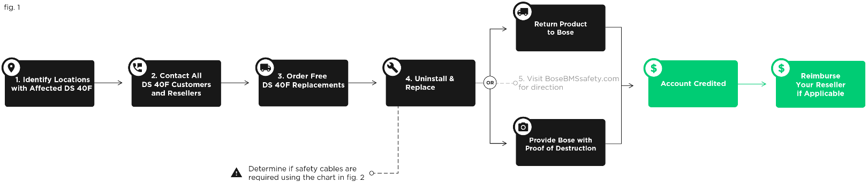

Managing the Recall for Your Reseller Customers

For your reseller customers, we ask that you order replacement products on their behalf. Then, when your reseller customers uninstall affected DS 40F loudspeakers and replace them with new DS 40F loudspeakers, they should return the recalled loudspeakers to you or provide you with proof of destruction in accordance with the instructions you receive at BoseBMSsafety.com. Your account will then be credited for your reseller customers’ installation costs following our receipt of a Compensation Request and return of the recalled loudspeakers to Bose or proof of their destruction per our instructions. You will then either credit your reseller customers’ account or pay them the reimbursement amounts. If you are unable or unwilling to manage the recall for your reseller customers as described here, please contact Bose immediately. Contact information can be found at BoseBMSsafety.com.

Safety Cable Installation — Required Action

Summary

The Bose loudspeakers and accessories listed below that are installed in commercial cooking environments where they are exposed to cooking oils or cooking oil fumes must be secured with a safety cable.

Products Affected

EdgeMax EM90 and EM180

FreeSpace DS 16 flush- and surface-mount (DS 16F, DS 16S, DS 16SE)

FreeSpace DS 40 flush- and surface-mount (DS 40F, DS 40SE)

FreeSpace DS 100 flush- and surface-mount (DS 100F, DS 100SE)

FreeSpace 3 Flush-Mount Satellites

FreeSpace 3 Series II Acoustimass (bass) module

Please refer to Document 6A (enclosed) for a complete list of all affected models of the above loudspeakers and their SKU numbers.

Please perform the following steps:

1. Identify all commercial cooking environments, such as restaurants and cafeterias, where you have installed the affected loudspeakers listed above. These loudspeakers will require inspection UNLESS you are certain that either:
   1. No cooking oil is used in the location;

OR

* 1. Only surface-mounted and/or pendant-mounted loudspeakers are installed in the location AND these loudspeakers are NOT installed in the same room where cooking oil is used.

If you are certain of either (a) or (b) for a location, no action is required for the loudspeakers installed in that location. Because the mounting components of the loudspeakers are not exposed to cooking oil or cooking oil fumes, they do not require a safety cable. If neither (a) nor (b) are true for a location, or if you are not certain of either (a) or (b) for a location, then you must inspect the location as described in (3) below.

1. Before each site inspection, visit BoseBMSsafety.com to order enough safety cables for the number of loudspeakers that are installed at the site you will inspect. Bose will provide these safety cables free of charge.

Note: The safety cable must be attached to a rear cover plate that covers the wiring terminals. If the rear cover plate is missing from the installed loudspeaker, please contact your Bose Professional sales representative.

IMPORTANT: For your reseller customers, we ask that you manage the safety cable ordering/compensation process for them as described below in the section “Managing Safety Cables for Your Reseller Customers.”

1. Arrange to visit the location for an on-site inspection. The next steps depend on what you find during your on-site inspection:
   1. IS COOKING OIL USED AT THE LOCATION? If NO, no further action is required. Because the mounting components of these loudspeakers are not exposed to cooking oil or cooking oil fumes, they do not require a safety cable. If YES, continue to (b) below.
   2. ARE THE LOUDSPEAKERS INSTALLED IN THE SAME ROOM WHERE COOKING OIL IS USED? If YES, you must install a safety cable on the loudspeakers. This applies to surface-mounted, pendant-mounted, in-ceiling/flush mounted loudspeakers. If NO, continue to (c) below.
   3. ARE THE LOUDSPEAKERS EITHER SURFACE-MOUNTED OR PENDANT-MOUNTED? If YES, no further action is required. Because the mounting components of these loudspeakers are not exposed to cooking oil or cooking oil fumes, they do not require a safety cable. If NO (i.e., they are in-ceiling/flush-mounted loudspeakers), continue to (d) below.
   4. ARE THE IN-CEILING/ FLUSH-MOUNTED LOUDSPEAKERS EXPOSED TO AIR FROM A ROOM WHERE COOKING OIL IS USED VIA AN HVAC SYSTEM WITH AN ABOVE-CEILING PLENUM RETURN? If NO, no further action is required. Because the mounting components of these loudspeakers are not exposed to cooking oil or cooking oil fumes, they do not require a safety cable. If YES or if you are unsure, you must install a safety cable on the loudspeakers.
2. Once the site visit is complete, submit a Compensation Request via BoseBMSsafety.com indicating the locations inspected and the number of safety cables installed. Your account will be credited following receipt of Compensation Request per Document 1A (enclosed).

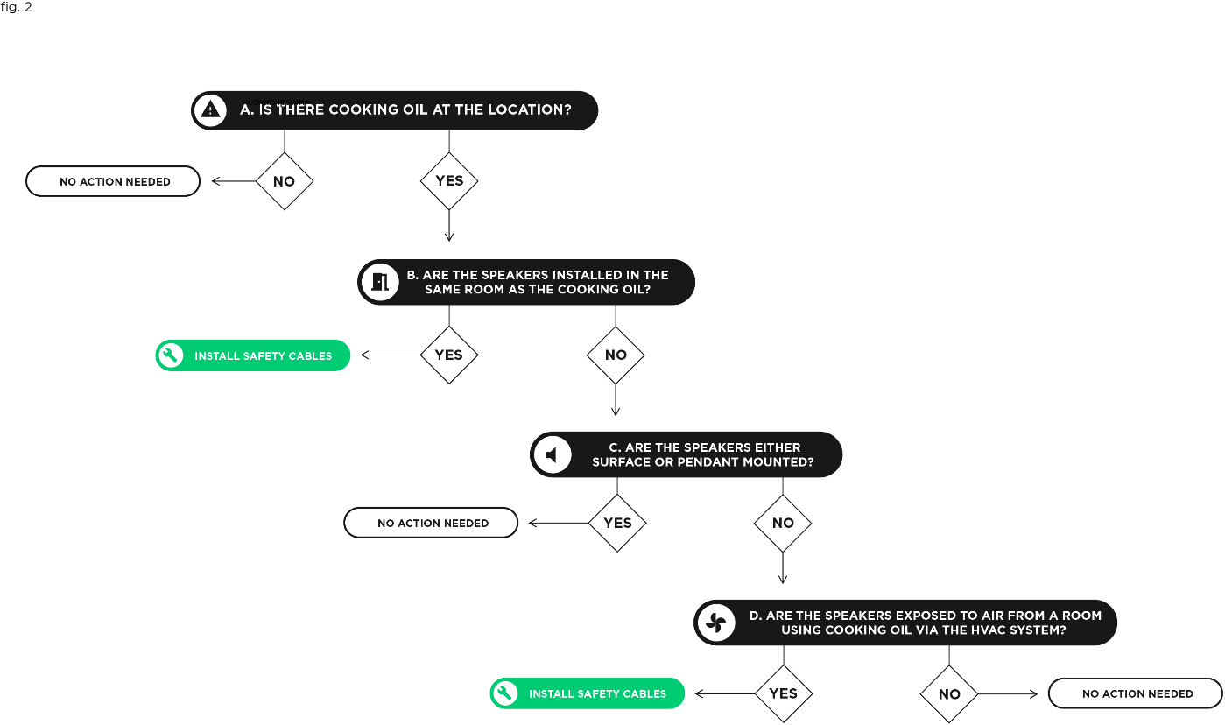

Managing Safety Cables for Your Reseller Customers

We ask that you order safety cables on behalf of your reseller customers. Once they inspect the affected loudspeakers as described above and install safety cables where needed, you will need to submit a Compensation Request for the reimbursement of their installation services via BoseBMSsafety.com. Your account will be credited for your reseller customers’ installation costs following receipt of Compensation Request, and you will either credit your reseller customer’s account or pay them the reimbursement amounts.

Additional Questions?

You can find more information and answers to many questions you may have at BoseBMSsafety.com. If you have questions or concerns not addressed there, please contact your Bose sales representative. Contact information can be found at BoseBMSsafety.com.



Document 6A