# **Overview**

This guide provides step-by-step instructions for manually updating your EX-UH USB/Headset Dante endpoint to ensure optimal performance. These instructions apply to ControlSpace Designer version 5.15.0 or later.

**Note:** The “UpgradeFirmware-1.0.30.0.exe” file is automatically installed with ControlSpace Designer version 5.15.0 or later. It is located in the "C:\Program Files (x86)\Bose Professional\ControlSpace 5.15\bin\Utilities\EX-UH" folder.

The firmware update file is available for download at: [Bose Professional: Pro Audio Equipment & Sound Systems](https://boseprofessional.com/)

# **Instructions for Manual Update of the EX-UH**

1. Download the EX-UH firmware update from the link above.
2. Plug the EX-UH into the computer using a micro USB cable.
3. Navigate to "C:\Program Files (x86)\Bose Professional\ControlSpace 5.15\bin\Utilities\EX-UH". Run the “UpgradeFirmware-1.0.30.0” Application by double clicking it. Verify under the Manufacturer and Product fields that the device is detected (see below).

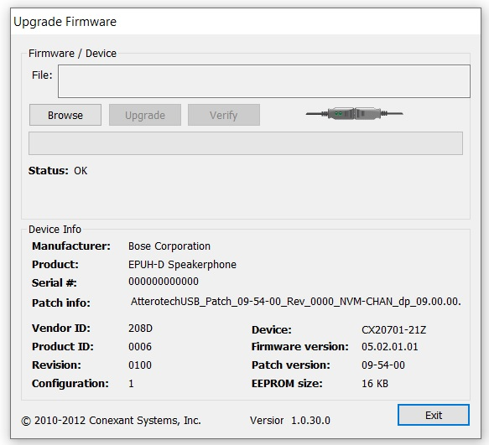

1. Click on the Browse button and navigate to the firmware file downloaded in step 1. Double click on the firmware file. Note that the patch file syntax is OK in the Status section of the updater application.

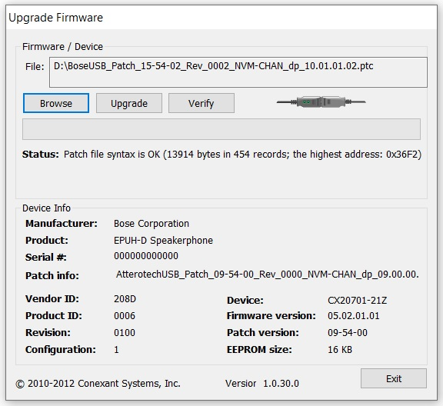

1. Click the Upgrade button. Then click OK to begin the update procedure. PLEASE DO NOT UNPLUG OR DISCONNECT the device during the update process.

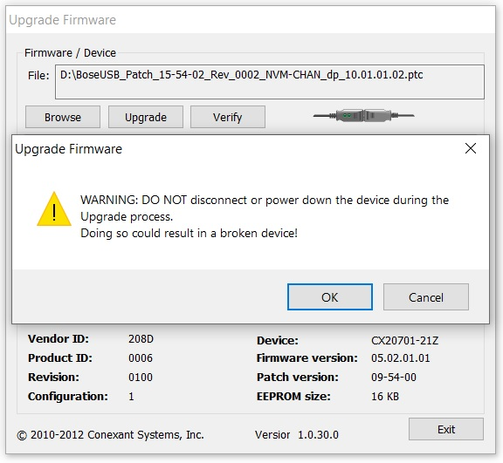

1. Your EX-UH should now be updated with the latest firmware. Click OK.

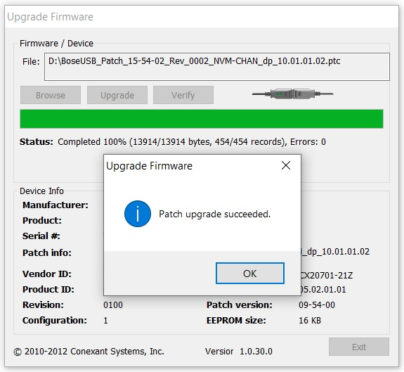

7. Please power cycle the EX-UH for the firmware changes to take effect.